|  |
| --- |
|  |
|  |
|  |
| FLOOD MONITORING |
| AND EARLY WARNING |

|  |
| --- |
| SUMMITTED BY ,  V.Praharsha  au723921243058  Praharshasingle@gmail.com |

DEVELOPMENT

part- 2

Developing an early warning platform is a complex task that involves multiple stages and components. To continue building this project, let's break it down into several key steps and components.

1. **Define Objectives and Requirements**:

- Clearly define the objectives of your early warning platform. What are you trying to monitor or predict? What are the critical events or risks you want to identify?

- Identify the specific requirements for the platform, including data sources, technology stack, and user interfaces.

2. **Data Collection and Integration**:

- Identify and collect relevant data sources. This could include real-time sensor data, historical records, social media feeds, weather data, or any other data sources relevant to your objectives.

- Develop data integration pipelines to collect and process this data in real-time. Tools like Apache Kafka or RabbitMQ can be used for data streaming.

3. **Data Processing and Analysis**:

- Implement data processing pipelines that can clean, preprocess, and analyze the incoming data.

4. **User Interface and Visualization**:

- Develop a user-friendly web-based dashboard or application where users can access real-time data and receive alerts.

- Include interactive visualizations and mapping tools to display relevant information.

5. **Alerting and Notification System**:

- Implement a robust alerting system that can send notifications via email, SMS, mobile app push notifications, or other communication channels.

- Ensure that alerts are timely and actionable, with clear information about the nature of the event and recommended actions.

6. **Scalability and Redundancy**:

- Design the platform to be scalable, so it can handle increasing data volume and user load.

- Implement redundancy and failover mechanisms to ensure system availability.

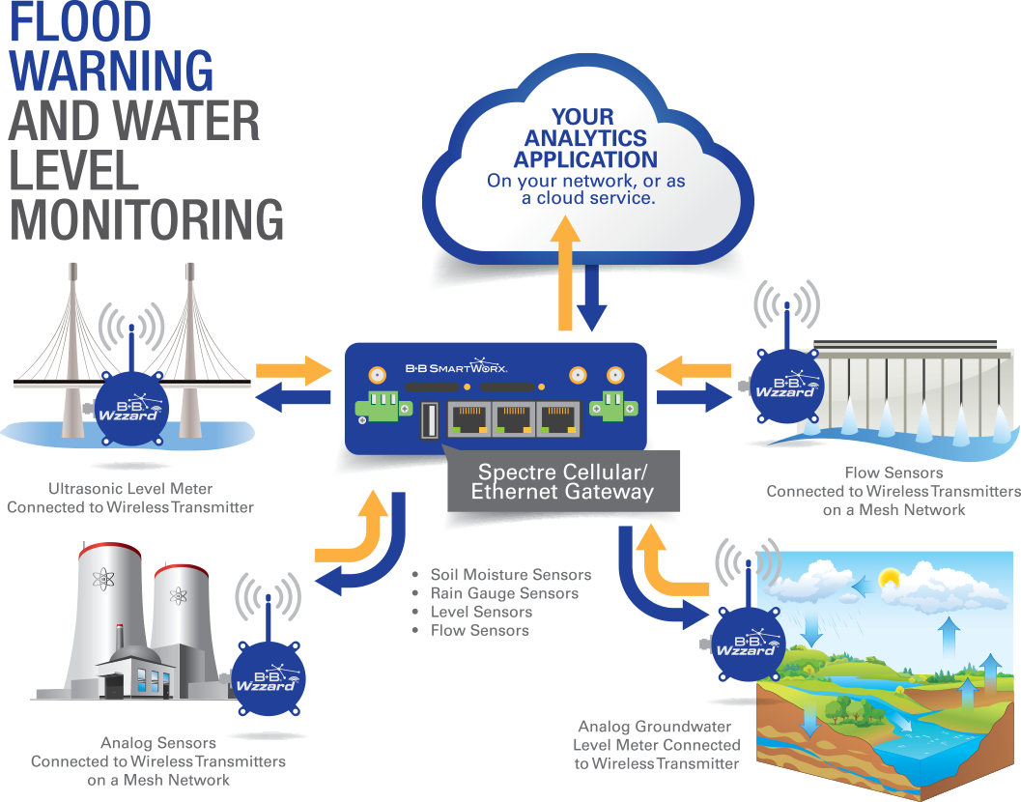

Creating a platform to display real-time water level data and flood warnings involves web development and integration with data sources and alerting systems. Here's a step-by-step guide on how to build such a platform:

1. **Define Objectives and Requirements**:

- Clearly define your objectives: monitoring water levels and providing flood warnings.

- Identify the data sources, including river gauge sensors and weather data.

- Determine the geographic area you want to cover and the scale of the project.

2. **Data Sources and Integration**:

- Identify and obtain access to real-time data sources for water levels and weather information. Public agencies, environmental organizations, and weather services may provide relevant data.

- Implement data integration pipelines to collect, clean, and update this data in real-time. You can use technologies like Node.js or Python for this purpose.

3. **Database and Data Storage**:

- Set up a database to store historical and real-time data. Technologies like PostgreSQL or MongoDB can be used.

- Design an efficient data schema to store water level measurements, timestamps, and other relevant information.

4. **Backend Development**:

- Develop a backend application that processes the collected data.

- Implement alerting and warning systems that trigger notifications based on predefined thresholds or predictive models.

- Utilize server-side programming languages such as Node.js, Python, or Ruby.

5. **API Development**:

- Create RESTful APIs to expose the real-time data, historical data, and warning information to the frontend.

- Ensure proper API documentation and version control.

# CODING:

import random

import time

# Simulated IoT sensor data

def simulate_sensor_data():

return random.uniform(0.0, 10.0) # Simulating water level (in meters)

# Function to check for flood conditions

def check_flood_conditions(sensor_data):

# Define a threshold for issuing flood warnings

threshold = 8.0 # Example threshold for issuing a warning

if sensor_data > threshold:

return True # Flood condition detected

else:

return False

# Function to issue flood warnings

def issue_flood_warning():

print("Flood warning issued! Seek higher ground immediately.")

# Main loop

while True:

# Simulate sensor data

sensor_data = simulate_sensor_data()

print(f"Water level: {sensor_data} meters")

# Check for flood conditions

if check_flood_conditions(sensor_data):

issue_flood_warning()

time.sleep(60) # Simulate data every minute

OUTPUT:

Water level: 5.374194217942502 meters

Water level: 2.193865905692104 meters

Water level: 9.893442115447747 meters

Flood warning issued! Seek higher ground immediately.

Water level: 3.8868540158740967 meters

Water level: 8.71943280304597 meters

Flood warning issued! Seek higher ground immediately.

...

# Conclusion:

In conclusion, building a comprehensive platform to receive and display water level data from IoT sensors and issue flood warnings is a complex task that involves multiple components and technologies. It's a critical system for enhancing public safety and flood preparedness. The platform typically includes IoT sensor data collection, data processing, flood condition detection, alerting, user interface, and more.